SHRI RAMDEOBABA COLLEGE OF ENGINEERING AND MANAGEMENT, NAGPUR.



Computer Network Lab Report

(6TH SEM, SESSION 2023-2024, ECP357)

“Connect military base to different emergency servers to detect any casualty”

**Submitted By__**

Siddhi Sahu 66 B4

Yugal Nasare 105 B4

**Group Number:** 6th

**Guide Name:** Dr. Puja S. Agrawal

# Department of Electronics and Communication Engineering

**CONTENT**

|  |  |
| --- | --- |
| Topic | Page Number |
| Introduction | 3 |
| OBJECTIVES | 4 |
| Theoritical Background | 4 |
| procedure | 5 |
| Additional Application | 5 |
| Simulation | 6 To11 |
| conclusion | 12 |
| REFERENCES | 12 |

# Experiment 10

**Aim:** Connect military base to different emergency servers to detect any casualty Requirement

* Cisco Packet Tracer Software.
* Proper setup on PC/Laptop.

# Introduction

Connecting a military base to various emergency servers is a critical aspect of modern military operations. This connectivity ensures that in the event of any casualty or emergency, the response is swift and coordinated.

Objective: The objective of this project is to create a system that connects a military base to different emergency servers, enabling the detection of casualties in real-time. This system aims to improve the response time and efficiency of emergency services in military operations.

Scope: The scope of this project includes designing and implementing a network infrastructure using Cisco Packet Tracer to connect the military base to various emergency servers. The system will be capable of detecting casualties through sensors and transmitting this information to the emergency servers for prompt response.  
  
Assumptions: It is assumed that the military base and emergency servers have reliable power sources and internet connectivity. Additionally, it is assumed that the sensors used for casualty detection are accurate and reliable.

Network Infrastructure: The network utilizes a wireless infrastructure, with a home gateway connecting the SBC-PT board wirelessly. The home gateway also connects to a tablet for data transfer to the main side.

**What is Home Gateway?** A home gateway is a device that serves as a central point of communication between devices in a home network and the internet. It typically includes a router, modem, and often additional features such as a firewall, DHCP server, and wireless access point.

DHCP Server: The DHCP server assigns IP addresses dynamically to devices on the home network. This allows devices to connect to the network without manual configuration of IP addresses. And benefits of this is to minimizes configuration errors caused by manual IP address configuration, such as typographical errors, or address conflicts caused by the assignment of an IP address to more than one computer at the same time.

Wireless Access Point: Many home gateways also include a wireless access point, which allows devices to connect to the network wirelessly using Wi-Fi. The home gateway serves as a central hub for the network, facilitating communication between the SBC-PT board, tablet, and other network devices. It manages wireless connections, routes data between devices, and provides a secure interface for network configuration and management.

**What is SBC-PT?**

SBC-PT stands for Single Board Computer with Packet Tracer. It is a simulated hardware device used in Cisco Packet Tracer to represent a single-board computer (SBC) that can be used in various network configurations.

In the context of your project, the SBC-PT board serves as a component in your network setup, connecting wirelessly to the home gateway. It functions as a computing device capable of running applications or scripts that help manage and control the network.

The SBC-PT board works by receiving and processing data from sensors or other devices in the network, such as the motion sensor in your project. It can also communicate with other devices in the network, such as the tablet, to transfer data or receive commands.

**Used of tablet hear** for receiving data and issuing commands to the network. A tablet device is integrated into the network to serve as a mobile interface for monitoring and controlling the network. The tablet receives data from the home gateway, providing real-time updates on network status and alerts from the motion sensor. Additionally, the tablet allows soldiers to remotely access and control the network, enabling them to take immediate action in response to detected intrusions.

**Functionality:**

* Receive real-time updates and alerts from the network, including intrusion detection notifications from the motion sensor.
* Provide a user-friendly interface for monitoring network status and controlling network devices.
* Enable remote access and control of the network, allowing soldiers to take immediate action in response to detected intrusion

**Objective**

The objective of this project was to design and implement a network infrastructure using Cisco Packet Tracer to connect a military base with various emergency servers. The system incorporates IoT devices such as temperature sensors, motion detectors, and wind detectors to detect casualties or emergencies in real-time, aiming to improve response times and efficiency in military operations.

**Theoretical Background**

The project aims to connect a military base to various emergency servers using Cisco Packet Tracer. By integrating IoT devices like temperature, motion, and wind detectors, the system can detect casualties in real-time. A home gateway acts as a central hub, connecting wirelessly to an SBC-PT board and tablet, facilitating seamless data transmission. The SBC-PT board processes sensor data, while the tablet provides a user-friendly interface for remote monitoring and control. Overall, the project demonstrates the effectiveness of IoT technology in enhancing military emergency response capabilities.

**Procedure:**

* Start by setting up the Temperature Sensor to monitor environmental conditions.
* Connect the sensor to an SBC (Single Board Computer) to process the temperature data.
* Configure the LCD to display temperature readings from the sensor.
* Set up the Air Cooler and Heating Element to activate based on certain temperature thresholds.
* Establish a Home Gateway as the central hub for all IoT devices.
* Ensure the gateway is wirelessly connected to the SBC for seamless data transmission.
* Integrate additional devices such as a Tablet/PC, Webcam, and Motion Detectors with the Home Gateway.
* Connect a Light and Siren to serve as visual and auditory indicators for alerts.
* Monitor the Temperature Monitor for real-time temperature updates.
* Program the system to trigger the light and siren when the motion detectors are activated or when temperature anomalies are detected.
* Test the system’s response to simulated temperature changes and motion detect
* Validate that the LCD displays accurate temperature readings and that the air cooler, heating element, light, and siren function as intended.

**Additional Applications**

The project's network infrastructure and IoT devices have additional applications beyond military bases. They can be used in various civilian emergency response scenarios, such as natural disasters or industrial accidents, to detect and respond to emergencies. The system's ability to monitor environmental conditions, detect motion, and communicate with emergency servers makes it suitable for enhancing safety and security in smart cities or industrial settings. Additionally, the network setup and devices can be adapted for use in home automation systems, providing remote monitoring and control capabilities for energy management and security purposes.

**Simulation**

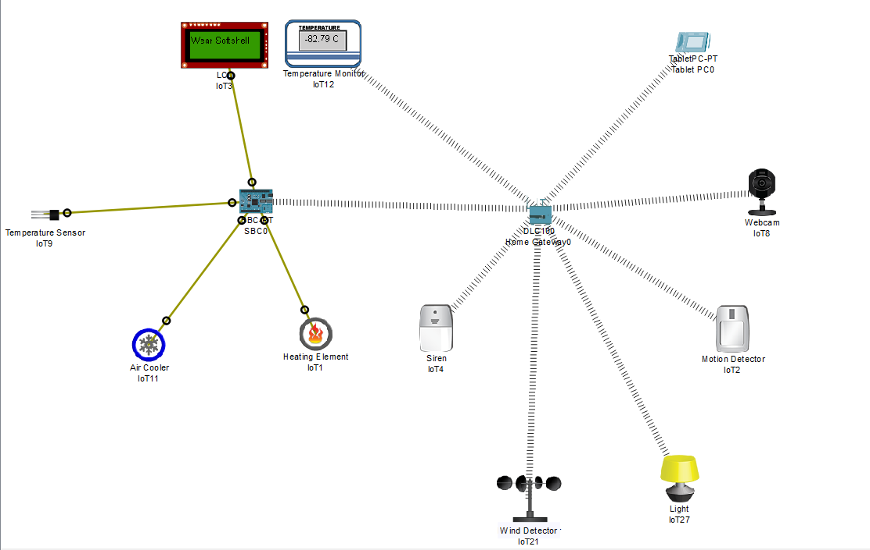 **Project Image:**

1. **Temperature sensor:**

Set an IP Address

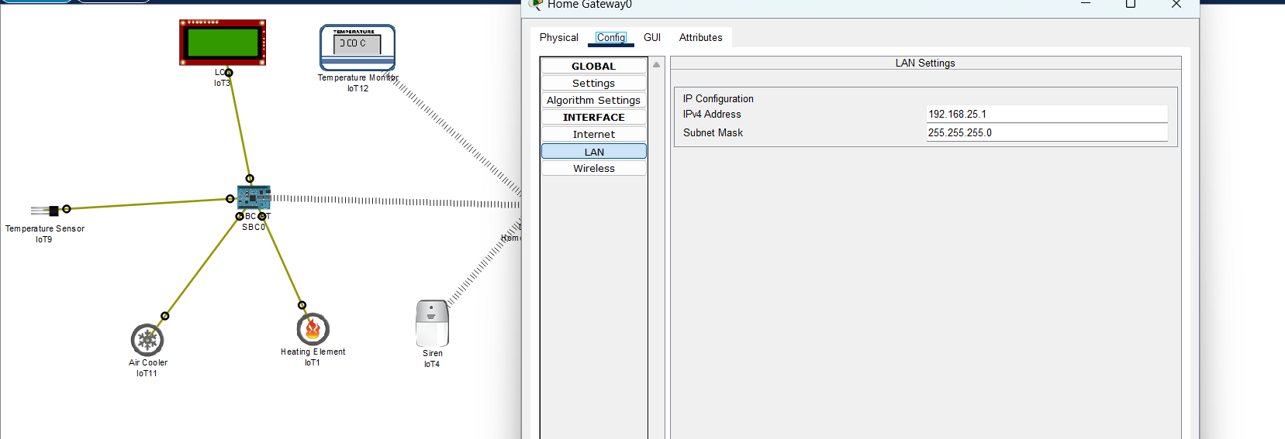

**SBC-PT bord to DHCP**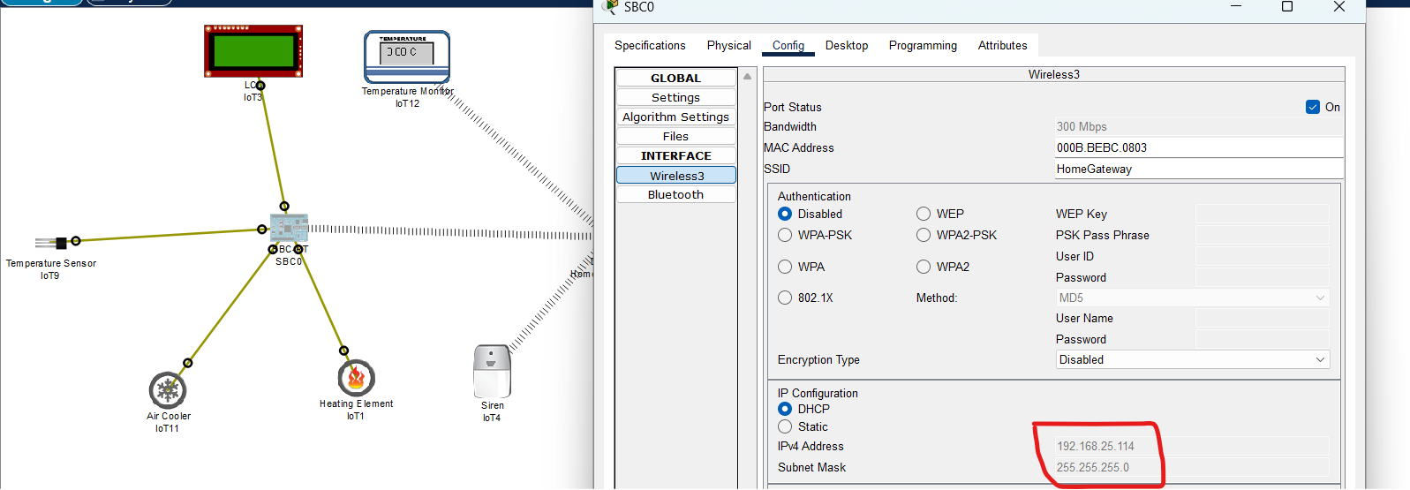

**Program for interfacing the Temperature sensor:**

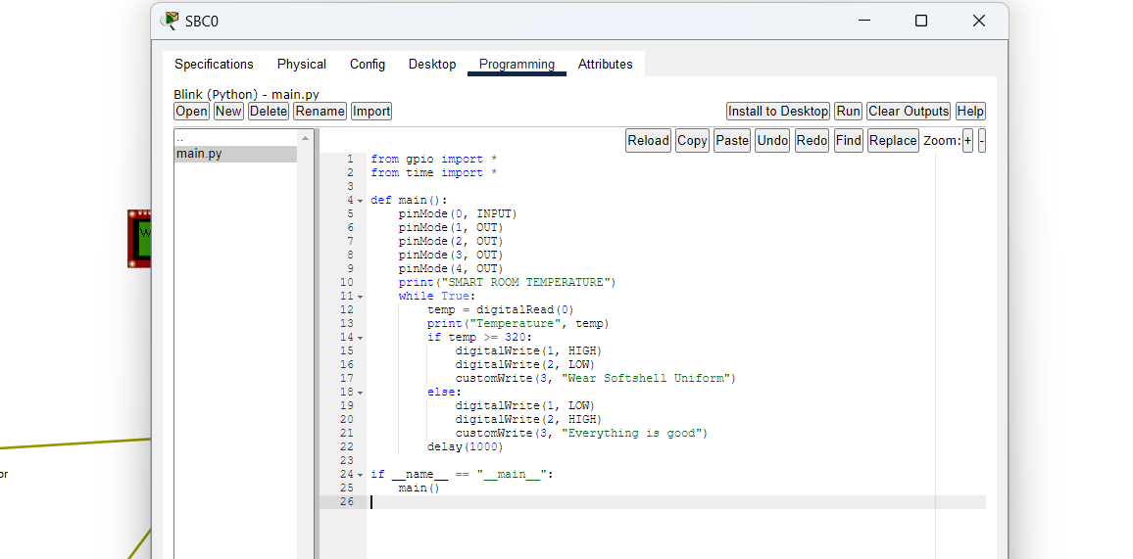

**Depending on the temperature it will display on the lcd whether the Soldiers need some proportions or not… (When temperature is heigh it will be Everything is good as per the code…)**

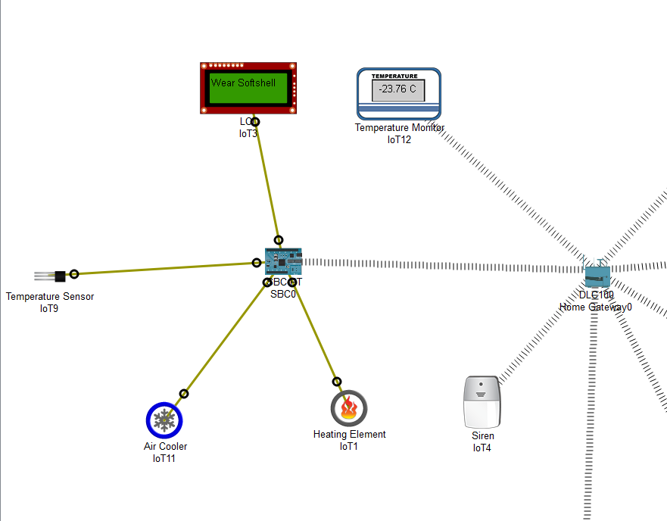

1. **Motion Detector**

**Whenever the enemies’ motion is detected, it will send its signal to the tablet.**

**Get a password from home Gateway:**

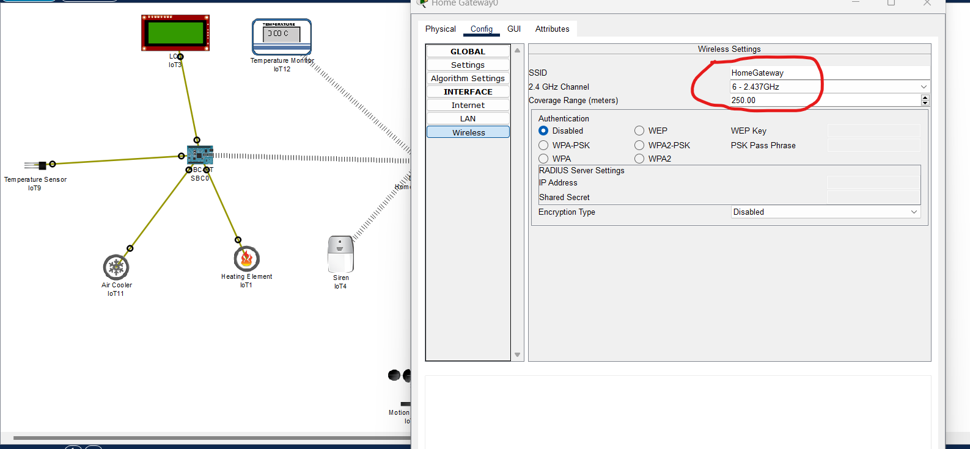

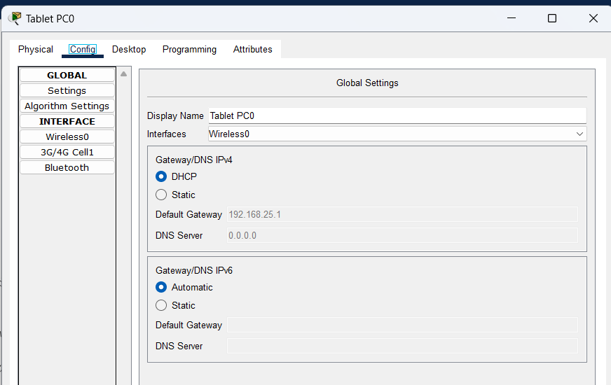 **In tablet set to the DHCP**

**For condition (In IOT monitor System)**

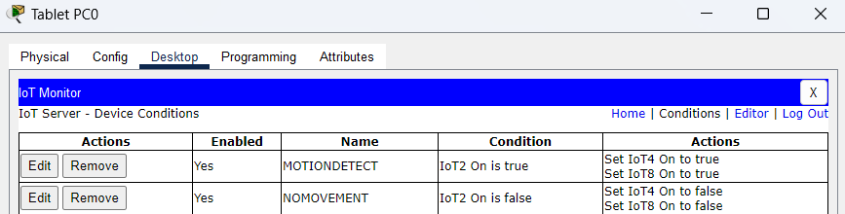

**Initially there will be no one in front of motion detector**

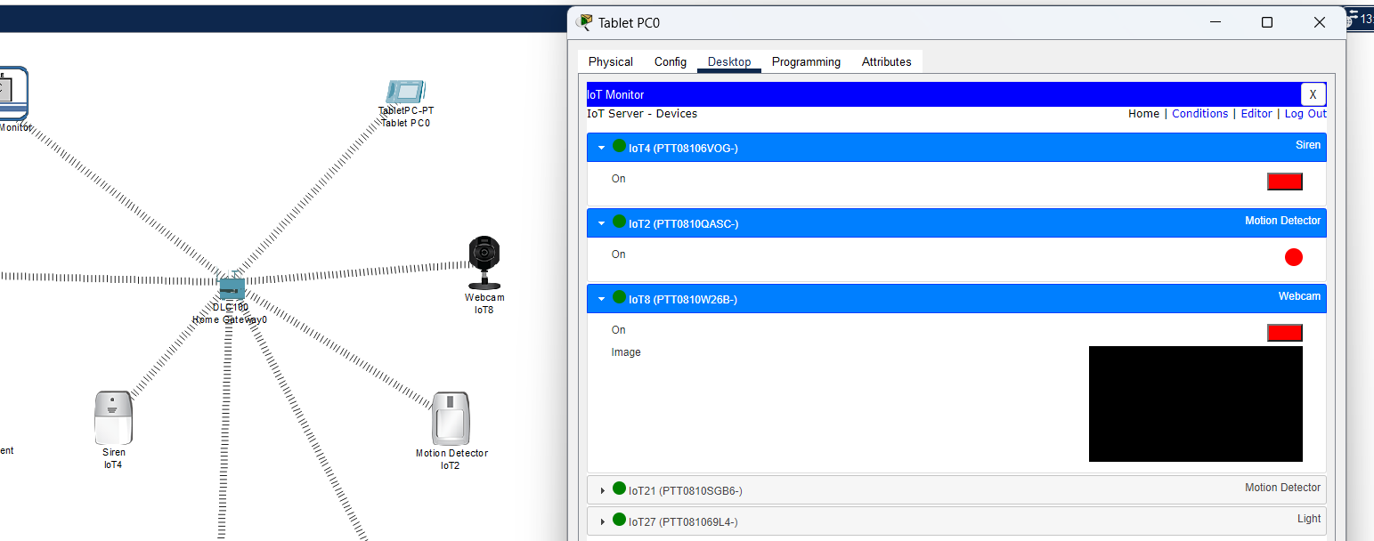

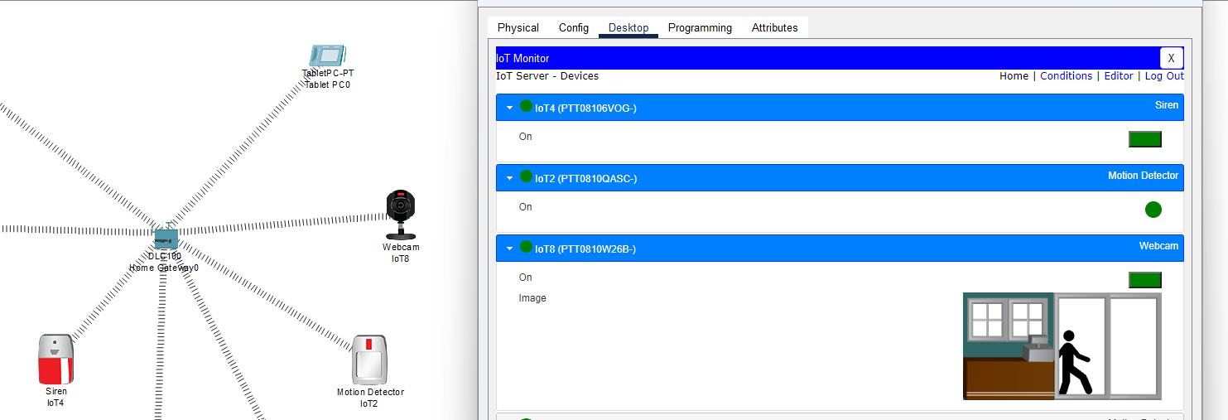**Whenever, someone is in front of motion detector it will be show some message**

1. **Wind Detector**

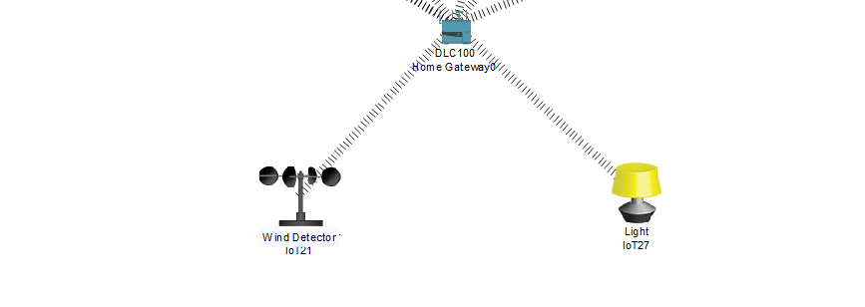

**Set Their Gateway DNS to the DHCP**

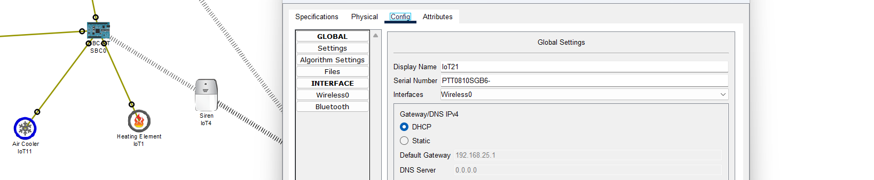

**For condition (In IOT monitor System)**

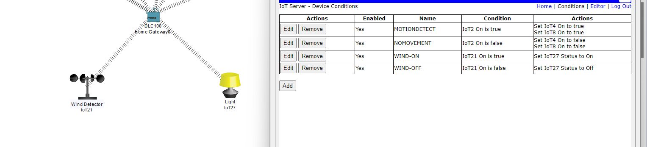

**Note: All IoT wireless devices must be connected to the IoT server on the home gateway.**



**Now, initially there will be no one in front of motion detector**

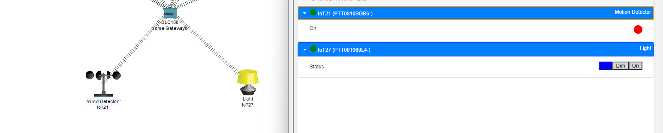

**Whenever the wind detector detects a very high air velocity, it will deflect.**

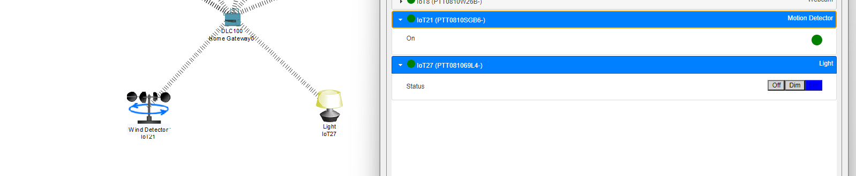

**Conclusion:**

The project has effectively demonstrated the implementation of a network infrastructure using Cisco Packet Tracer to connect a military base with different emergency servers. By integrating various IoT devices such as temperature sensors, motion detectors, and wind detectors, the system can detect and responding to potential casualties or emergencies in real-time.

The utilization of a home gateway as the central hub, connecting wirelessly to the SBC-PT board and tablet, showcases a robust communication framework. The SBC-PT board serves as a computing device to process data from sensors, while the tablet provides a user-friendly interface for monitoring and controlling the network remotely.

Moreover, the project highlights the importance of connectivity and automation in modern military operations, aiming to improve response times and overall efficiency during critical situations. The system's ability to trigger alerts, activate devices such as air coolers and heating elements based on temperature thresholds, and monitor environmental conditions demonstrates its practicality and effectiveness in enhancing military emergency response capabilities.

Overall, this project serves as a successful example of integrating IoT technology into military operations, showcasing its potential to significantly enhance emergency response capabilities and improve the overall effectiveness of military bases in ensuring the safety and security of personnel.

**References:**

1. **Data Communications and Networking** with TCPIP Protocol Suite| 6th Edition. by Behrouz A. Forouzan | 3 August 2022 | Standard Edition Edition.
2. **Data Communications and Networking** with TCPIP Protocol Suite| 6th Edition. by Behrouz A. Forouzan | 3 August 2022 | Standard Edition Edition.
3. **Data Communications and Networking** with TCPIP Protocol Suite| 6th Edition. by Behrouz A. Forouzan | 3 August 2022 | Standard Edition Edition.
4. Looking for books by Behrouz A. Forouzan? See all books authored by Behrouz A. Forouzan, including **Data Communications and Networking**, and Data Structures: ...